**Code Coverage Report**

**Test Data 1:**

File Name: td1.txt

File Content:

**token => [a] and [b] or 'c' with #d and `e`, 124;**

**string xor (num) "value"**

Coverage Percentage: **82.8%**

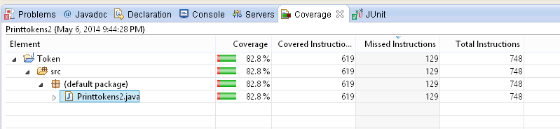

**Test Data 2:**

File Name: null

System.in Content:

**Token123 if {a} lambda ‘b’ isNULL;comment**

Coverage Percentage: **60.3%** (Which covered few missing lines of Test Data 1)

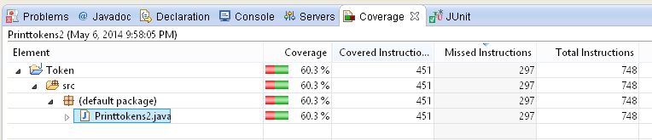

**Overall Cove Coverage Percentage: 86% (approximate)**